INDEX

|  |  |  |  |
| --- | --- | --- | --- |
| **Sr.**  **No.** | **Chapter** | **Context** | **Page**  **No.** |
| **1.** | **CH:1** | **Introduction Of project** |  |
|  | 1.1 | Introduction on Project | 5 |
|  | 1.2 | Project Definition | 5 |
|  | 1.3 | Object & Scope of Project | 6 - 7 |
| **2.** | **CH:2** | **Project Description** |  |
|  | 2.1 | Study of Problem | 8 |
|  | 2.1.1 | S/w & Device Requirement | 9 |
|  | 2.1.2 | Specification Requirement | 10 |
|  | 2.1.3 | Backend Technology | 11 |
|  | 2.1.4 | Frontend Technology | 11 |
|  | 2.2 | System Analysis | 12 |
|  | 2.3 | System Diagrams |  |
|  | 2.3.1 | Data Diagram | 17 |
|  | 2.3.3 | Flow Chart | 18 |
|  | 2.3.4 | ER Diagram | 19 |

|  |  |  |  |
| --- | --- | --- | --- |
|  | 2.3.6 | Use Case Diagram (UML) | 20 |
| **3.** | **CH:3** | **Advantages And Disadvantage** |  |
|  | 3.1 | Advantages And Disadvantages | 25 |
| **4.** | **CH:4** | **Bibliography** |  |
|  | 4.1 | Bibliography | 26 |

**TABLE INDEX**

|  |  |  |
| --- | --- | --- |
| **Chapter** | **Context** | **Page**  **No.** |
| **CH:2** | **Project Description** |  |
| 2.1 | S/w & Device Requirement | 9 |
| **2.3.1** | **Data Diagram** | 20 |
|  | 2.2 Login | 23 |
|  | 2.3 About us | 23 |
|  | 2.4 Contact us | 23 |
|  | 2.5 Home | 24 |
|  | 2.6 Cryptocurrency | 24 |

FIGURE INDEX

|  |  |  |
| --- | --- | --- |
| **Chapter** | **Context** | **Page**  **No.** |
| 3.1 Flowchart Diagram | | 18 |
| 3.2 ER Diagram |  | 19 |
| 3.3 Data Flow Diagram | | 15 |
| 3.4 Use-Case Diagram | | 22 |



## Logo, company name Description automatically generatedSIGMA INSTITUTE OF ENGINEERING

Ajwa-Nimata Road, Bakrol, Ta.: Waghodia, Vadodara – 390019

**Contact :(91)-9909976831, 0265-267111, 267122**

[***www.sigmainstitute.org***](http://www.sigmainstitute.org/#_blank)

## PROJECT REPORT ON

E-Commerce Cross Platform



**SUBMITTED BY: GUIDED BY:**

|  |  |
| --- | --- |
| **MEET MANGUKIYA (196480307017)** |  |
|  |  |
|  |  |

**Certificate**

## This is To Certify That MEET MANGUKIYA (196480307017), OF SIGMA INSTITUTE OF TECHNOLOGY & ENGINEERING (POLY)- 648 Have

Completed Final Project Report Having Title E-Commerce Cross Platform In Alone Consisting of 1 Persons Under The Guidance OF Mr. KAMLESH PARMAR.

Institute Guide–UDP Head of Department

DATE: DATE:

### ACKNOWLEDGEMENT

We are extremely Thankful to SIGMA INSTITUTES OF TECHNOLOGY & ENGINEERING (POLYTECHNIC) for giving the source and support in this project.

We had taken help and guideline of some respected persons, who deserve our greatest gratitude to our PRINCIPAL Mr. PREYESH GANDHI. We would like to show our gratitude to our HOD Mr. SHREYAS PATEL for giving us a good guideline for our project throughout the year. We would also like to expand our deepest gratitude to Mr. KAMLESH PARMAR and all our faculties who have directly and indirectly guided us in this project.

Many persons, especially our classmates and team members itself, have made valuable comment suggestions on this proposal which gave us an inspiration to improve our project. We also thank our parents for their support.

INDEX

|  |  |
| --- | --- |
|  | |
| *1. INTRODUCTION OF PROJECT* | *5* |
| *1.1 INTRODUCTION* | *5* |
| *1.2 PROJECT DEFINATION* | *5* |
| *1.3 OBJECTIVE AND SCOPE OF PROJECT* | *5-7* |
| *2. PROJECT DESCRIPTION* | *8* |
| *2.1 STUDY OF PROBLEM* | *9* |
| *2.1.1 HARDWARE, SOFTWARE, DEVICE REQUIRMENTS* | *10* |
| *2.1.2 SPECIFICATION REQUIRMENTS* | *11* |
| *2.2 SYSTEM ANALYSIS* | *12* |
| *2.2.1 SOFTWARE INTRODUCTION* | *12* |
| *2.2.2 SYSTEM MODEL* | *13* |
| *2.3 SYSTEM DIAGRAM* | *14* |
| *2.3.2 DIAGRAMS* | *19* |
| *2.3.2.1 FLOWCHART* | *20* |
| *2.3.2.2 ER-DIAGRAM* | *21* |
| *2.3.2.3 DATA FLOW DIAGRAM* | *22* |
| *2.3.2.4 USE CASE DIAGRAM(UML)* | *25* |
| *2.4 DESIGNING* | *26* |
| *2.4.1 HOME FORM* | *26* |
| *2.4.2 REGISTRATION FORM* | *26* |
| *2.4.3 LOGIN FORM* | *26* |
| *3. ADVANTANGES & DISADVANTAGES* | *27* |
| *3.1 FUTURE SCOPE* | *27* |
| *3.2 BIBLIOGRAPHY* | *28* |

#### INTRODUCTION

* + - We live in a digital age. How we communicate, shop, entertain ourselves, take care of our health and order groceries, all look significantly different than how we would have done it just 20 years ago. Banking and finance are also changing. And so is money.
    - We already have digital money – trillions move every day, electronically. But are we on the cusp of Digital Money 2.0? Not the account-based electronic money that’s been around for the past several decades, but a new type of token-based digital money. Tokenization, often via blockchain known as cryptocurrency.
    - Cryptocurrencies are digital or virtual assets that are encrypted using cryptography. Cryptography, on the other hand, refers to the application of encryption technology to secure and verify transactions. The cryptocurrencies are designed to function as a decentralized medium of exchange. The digital currencies are also classified as alternative currencies and virtual currencies.

#### PROJECT DEFINITION

* Where u can apply for your own wallet (online app) in which u can hold your currency.
* So, our name crypto hub itself says about our website which is the hub of cryptocurrency from history and its information to buying your own token or coin and checking the stokes.
* Crypto hub is a website on cryptocurrency which consists of:
  + Information and history about what are cryptocurrency and how it works.
  + Live share price of cryptocurrency with current values, market cap value and the percentage value of price hike in the last 24 hours.
  + Reference links of buying the cryptocurrency

#### OBJECTIVE

* + - Over time we’ve seen everyday things go digital. Sharing information through letters, newspapers, and books has turned into sharing emails and reading online. So, it’s only logical to predict that money will also be digitised.
    - Young people are increasingly drawn to cryptocurrencies as a way to make easy money. But their inexperience with investing makes them even more vulnerable to an already high-risk investment. And so, our main objective is to give them some knowledge through our website and to give them the pathway of investing in cryptocurrency.
    - The Indian government does not want to be left behind in the new age tech revolution and aims to cash in on the benefits blockchain technology offers. The time has come to leverage its applications while at the same time strengthening the digital infrastructure and so we think this is the best step to take towards the new age tech revolution (digital money 2.0).

#### SCOPE OF PROJECT

* + - * As per January 2021, there are 450 billion crypto coins there in the world and in last 8 months bitcoin (one of the cryptocurrencies) got the profit margin of 537% of its base value. So, if Indians enter in this market than the values of the coins can break records.
      * At present there are only 3.6 million Indian users out of 300 million users across the world who use crypto for investments and payments.
      * Many multinational companies are already accepting crypto payments and for that you should have crypto currency and its knowledge which can be gained by our website.

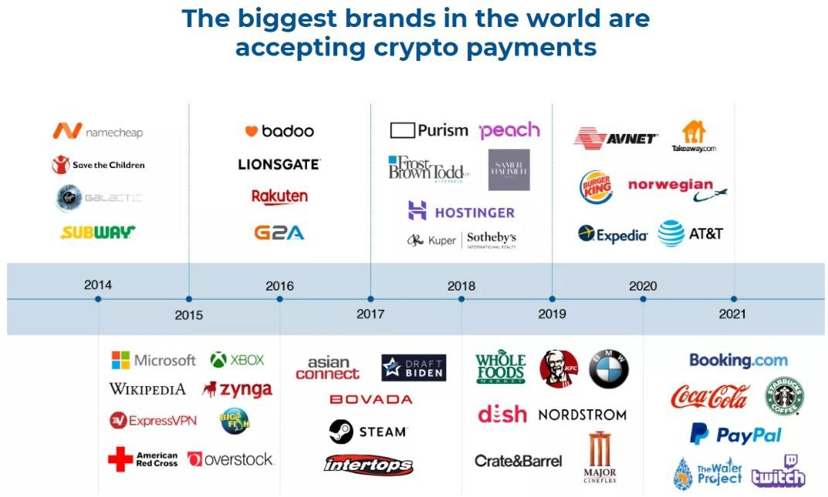

### STUDY OF PROBLEM

#### SOFTWARE REQUIRMENTS:

* To run PHP code, you need the following three software on your local machine:
  + 1. Web Server (Apache)
    2. PHP (Interpreter)
    3. MySQL Databases

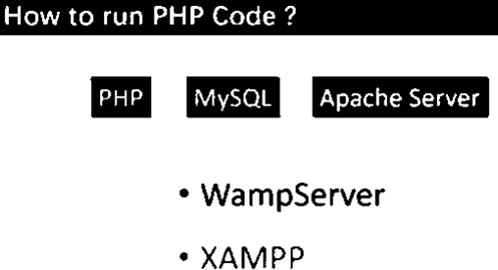

#### FRONT END AND BACK-END TECHNOLOGY

* + - * Front-end developers work with visual designs, creating impressive user experience. The most commonly used languages a front-end Web developer uses are: HTML, CSS3, and JavaScript. While the Back-end developer will work with huge amount of data, algorithms, and optimization of complex systems. Most used back-end web technologies are Python, Java, Ruby, and PHP.
      * While appearance comes under Front-end; storage, logic comes under Back-end.



### BACKEND TECHNOLOGY:

#### ABOUT PHP

PHP was originally created by Danish Canadian [programmer](https://en.wikipedia.org/wiki/Programmer) [Rasmus Lerdorf](https://en.wikipedia.org/wiki/Rasmus_Lerdorf) in 1994. The PHP [reference](https://en.wikipedia.org/wiki/Reference_implementation) [implementation](https://en.wikipedia.org/wiki/Reference_implementation) is now produced by The PHP Group. PHP originally stood for Personal Home Page, but it now stands for the [recursive initialism](https://en.wikipedia.org/wiki/Recursive_initialism) PHP: Hypertext Pre-processor.

PHP (Hypertext Pre-processor) is known as a general-purpose scripting language that can be used to develop dynamic and interactive websites. It was among the first server-side languages that could be embedded into HTML, making it easier to add functionality to web pages without needing to call external files for data.



### SYSTEM ANALYSIS

#### ABOUT SOFTWARE

W3Techs reports that, as of April 2021, "PHP is used by 79.2% of all the websites whose server-side programming language we know.”

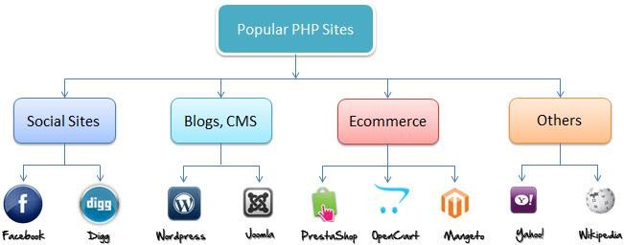

### Advantages of PHP

* Easy and Simple to Learn. PHP is considered one of the easiest scripting languages.
* Extremely Flexible.
* Easy Integration and Compatibility.
* Efficient Performance.
* Cost-Efficient.
* Gives Web Developer More Control.

### SYSTEM MODEL

**Spiral Model**

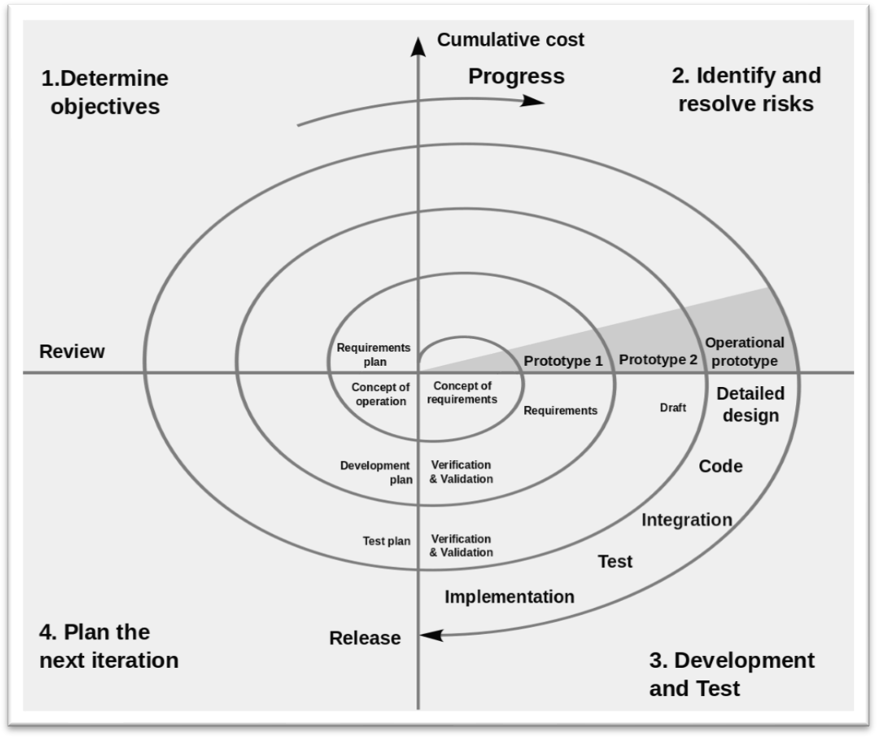

### STUDY FEASIBILITY

A feasibility study is defined as an evaluation or analysis of the potential impact of a proposed project or program**.** A feasibility study is conducted to assist decision-makers in determining whether or not to implement a particular project or program.

# Technical feasibility

At this level, the concern is whether the proposal is both *technically* and [*legally*](https://en.wikipedia.org/wiki/Legally) feasible (assuming moderate cost).

The technical feasibility assessment is focused on gaining an understanding of the present technical resources of the organization and their applicability to the expected needs of the proposed system. It is an evaluation of the hardware and software and how it meets the need of the proposed system.

# Financial feasibility

In case of a new project, financial viability can be judged on the following parameters:

* + - * + Total estimated cost of the project.
        + Financing of the project in terms of its capital structure, debt to equity ratio and promoter's share of total cost
        + Existing investment by the promoter in any other business
        + Projected cash flow and profit ability.

# Economic feasibility

Economic feasibility is the cost and logistical outlook for a business project or endeavour. Prior to embarking on a new venture, most businesses conduct an economic feasibility study, which is a study that analyses data to determine whether the cost of the prospective new venture will ultimately be profitable to the company.

* 1. **SYSTEM DIAGRAM**

# DATA DICTIONARY

LOGIN

|  |  |  |  |  |
| --- | --- | --- | --- | --- |
| **Column** | **Type** | **Null** | **Default** | **Constraint s** |
| User_id | INT (50) | NO |  | *(Primary Key) + Auto Increment* |
| Full_name | VARCHAR (50) | NO |  |  |
| Contact | VARCHAR (10) | YES | NULL |  |
| Address | VARCHAR (200) | YES | NULL |  |
| Email | VARCHAR (30) | NO |  |  |
| Password | VARCHAR (50) | NO |  |  |

CONTACT US

|  |  |  |  |  |
| --- | --- | --- | --- | --- |
| **Column** | **Type** | **Null** | **Default** | **Constraints** |
| Contact_id | INT (11) | NO |  | *(Primary Key) + Auto Increment* |
| Full_name | VARCHAR (50) | NO |  |  |
| Email | VARCHAR (50) | NO |  |  |
| Message | VARCHAR (200) | NO |  |  |

* + 1. **DIAGRAMS**

#### FLOWCHART:

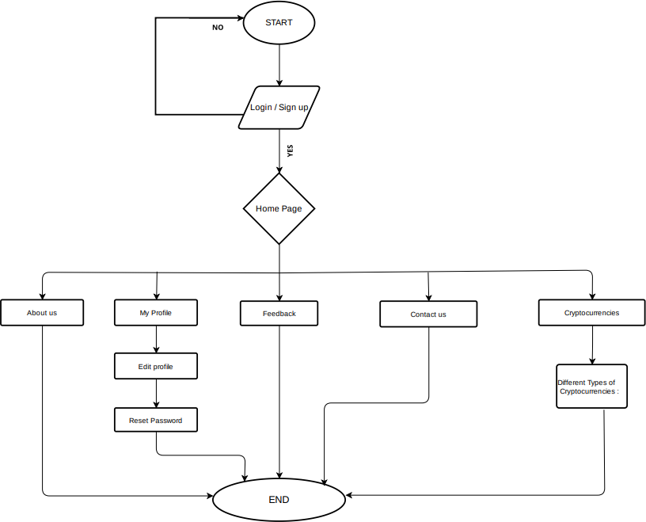

* + - 1. 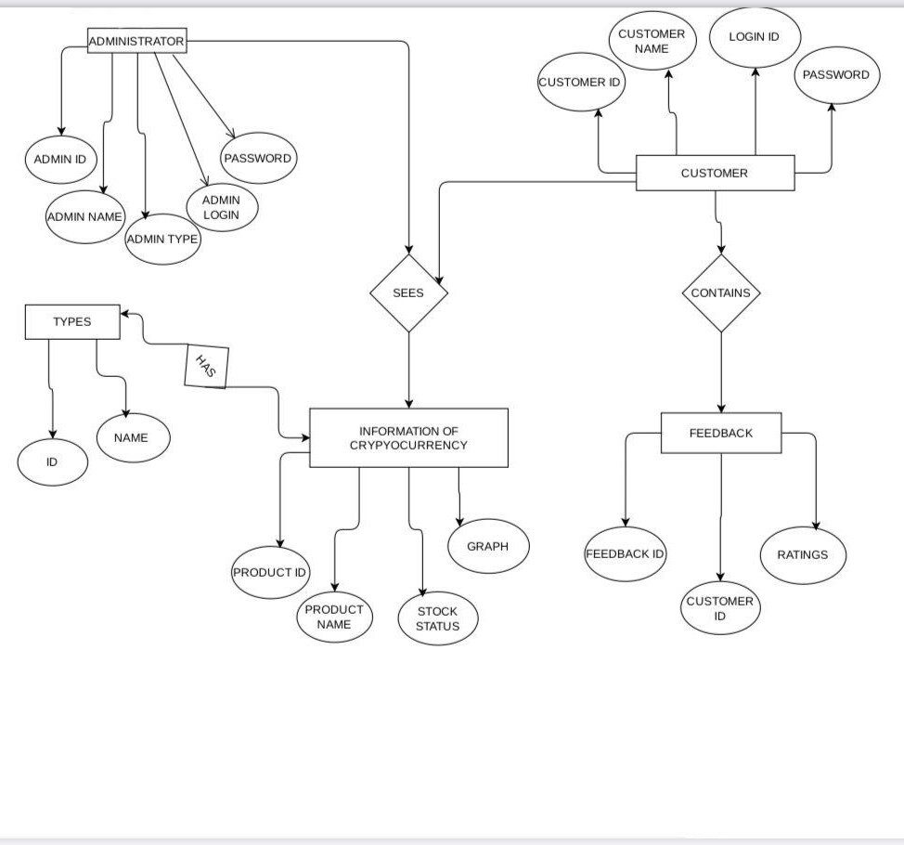**ER-DIAGRAM:**

### Data Flow Diagram

**LEVEL 0.0**

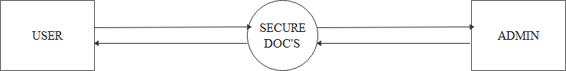

CRYPTO

HUB

### Diagram, schematic Description automatically generatedCUSTOMER LEVEL 1.0

**ADMIN LEVEL 2.0**

**ADMIN LEVEL 2.0**

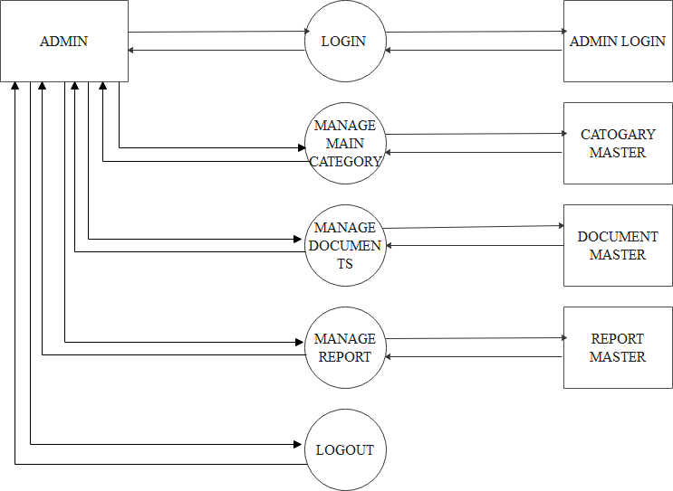

### USE CASE DIAGRAM:

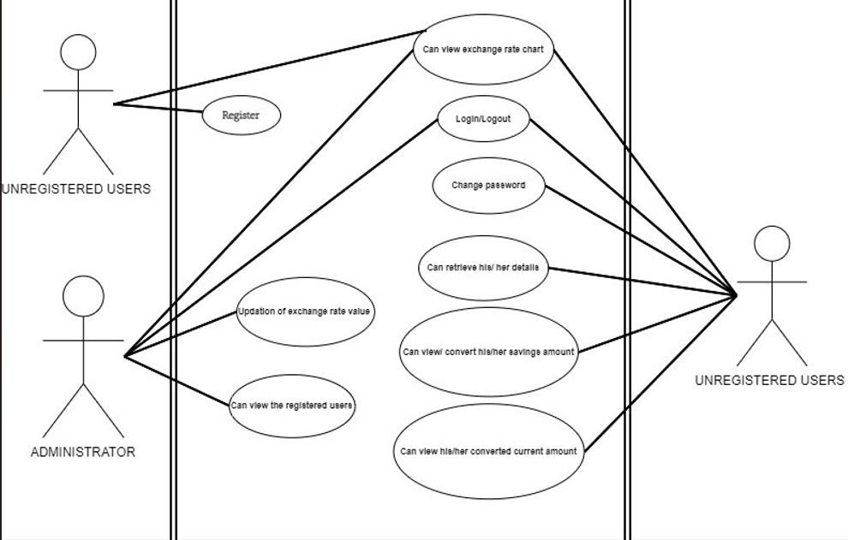

* 1. **DESIGNING**

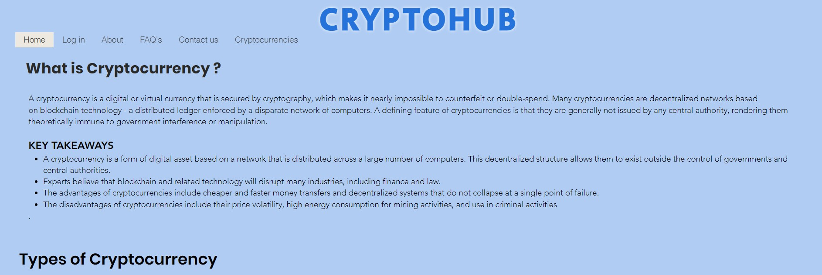

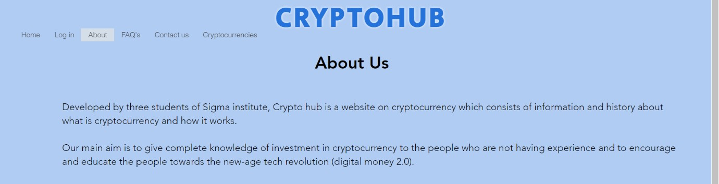

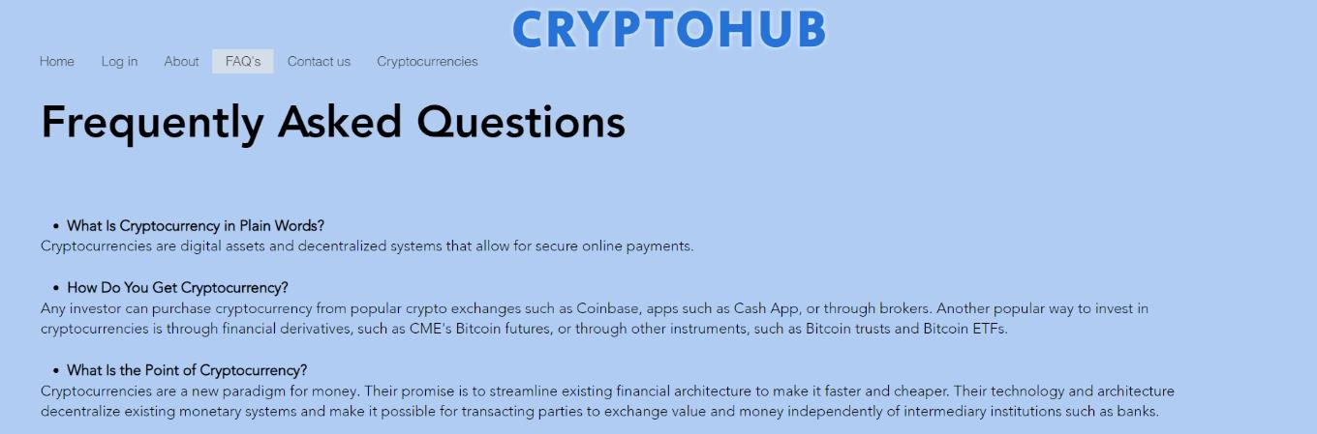

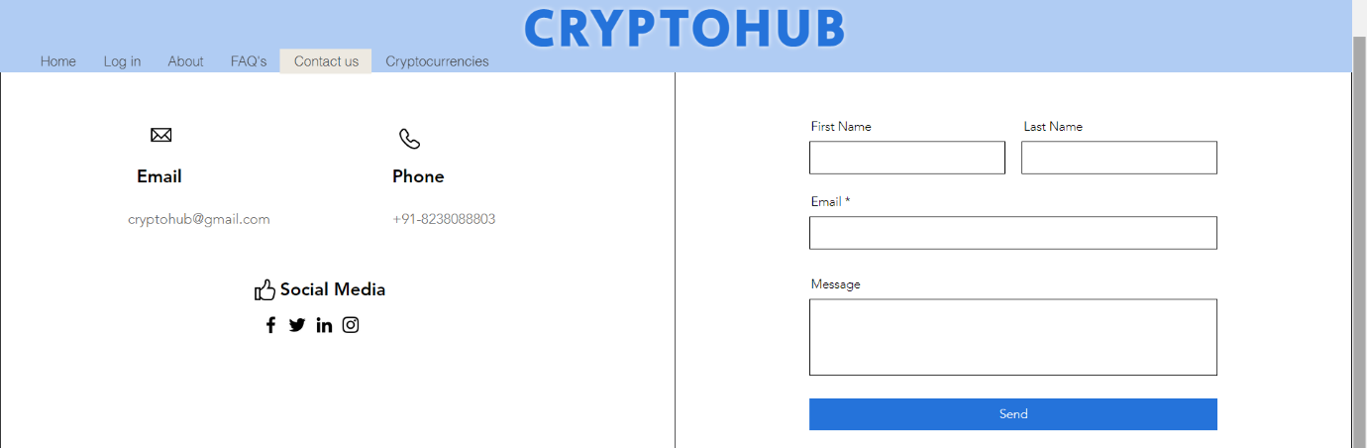

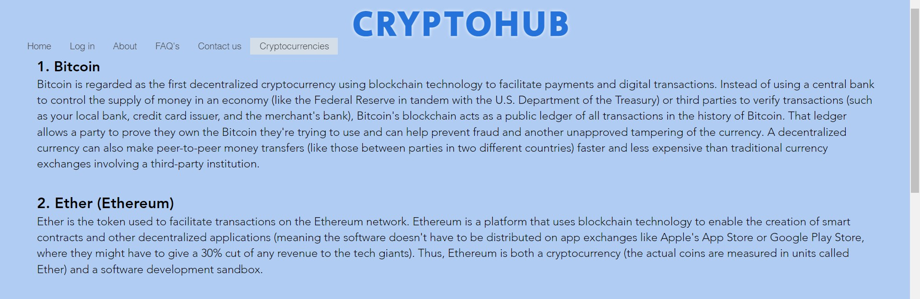

### ADVANTANGES AND DISADVANTAGES

* ADVANTAGES:
  + A to Z information about cryptocurrency
  + Easy to access.
  + Easily available on internet.
  + 24/7availability.
  + Saving money.
  + More security and privacy.
* DISADVANTAGES:
  + Internet is must.
  + Once the transaction is done it can never be retrieved.

### FUTURE SCOPE

* To bring the revenue model by inviting popular cryptocurrency trading websites and applications.
* To keep live exchange values of cryptocurrencies.

### 3.2.2 BIBLIOGRAPHY

<https://en.wikipedia.org/wiki/Cryptocurrency> <https://www.investopedia.com/terms/c/cryptocurrency.asp> <https://coinmarketcap.com/> <https://www.coindesk.com/price/bitcoin/>